Name: ___________________
Date: ___________
# _____
Ladybug Habitat
- What is the definition for a habitat?
__________________________________________________________________________
__________________________________________________________________________
__________________________________________.
- What are the characteristics of a ladybug’s habitat?
__________________________________________________________________________
__________________________________________________________________________
__________________________________________.
- What is the difference between a habitat and an environment? If there is no difference, convince me to why you think this.
__________________________________________________________________________
__________________________________________________________________________
__________________________________________.

- How is your habitat similar and/or different than a ladybug’s habitat?
__________________________________________________________________________
__________________________________________________________________________
__________________________________________.

- Identify where ladybugs can be found on the map below.

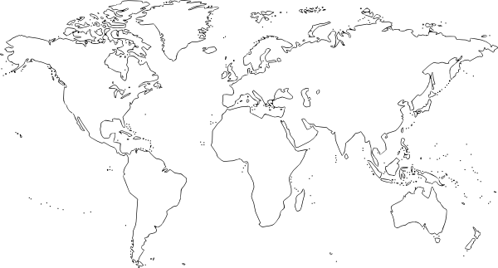

- Is there any human or natural events occurring in these regions that could be effecting the population of ladybugs? Explain.
__________________________________________________________________________
__________________________________________________________________________
__________________________________________________________________________
__________________________________________________________________________
__________________________________________________________________________
__________________________________________________________________________
__________________________________________________________________________.

